Shustoke Sailing Club
Reservoir Drive
Shustoke
Coleshill
B46 2BE
For travel directions to Shustoke Sailing Club enter your postcode in the Address box
below then click Get Directions.
SHUSTOKE SAILING CLUB
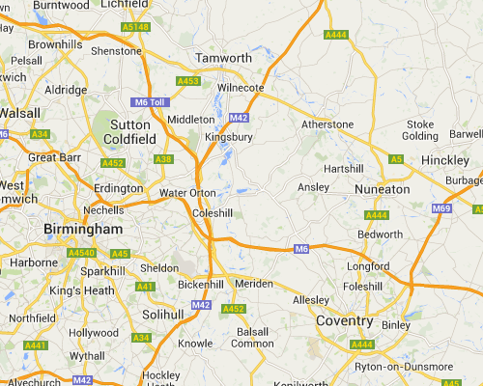
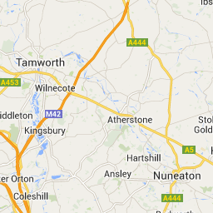
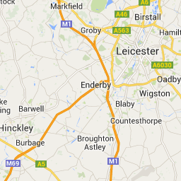
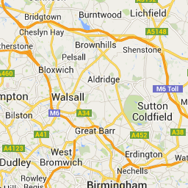
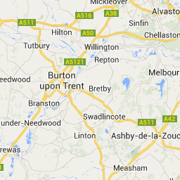
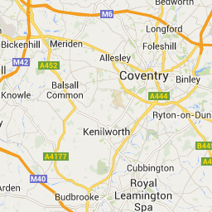
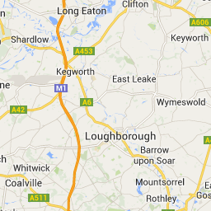
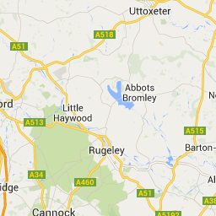
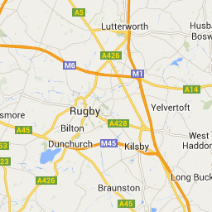
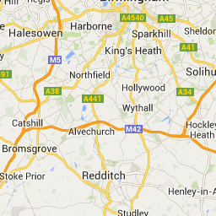

Map DataMap data ©2014 Google

Map data ©2014 Google
Terms of Use
Report a map error

Map

Satellite

Earth

